MESSAGE
FOR THE 120TH ANNIVERSARY
OF THE FOUNDATION

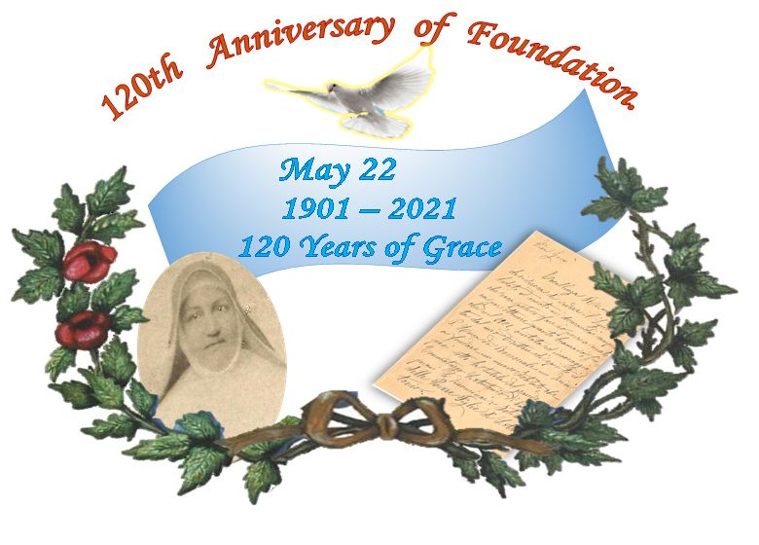

“Eager to see the Lord praised and loved, I always wondered what I poor creature could do to obtain what I longed for, until in 1901, helped and encouraged by my Spiritual Director, Father Luca of Boscoreale, I decided to found a new Institute, which I placed under the tutelage of the great Thaumaturge Saint Anthony of Padua, for which I called it "Institute of the Poor Daughters of St. Anthony”.
(Mother Miradio, Palma Campania, July 9, 1925)

Next May 22 is a day for us Religious Franciscan of Saint Anthony to live in joy and gratitude: we will celebrate the 120th Anniversary of Foundation.
Safeguarding and reinvigorating historical memory is a responsible duty because honoring the past, we give strength to the future and the present becomes a celebration. Remembering is a way of safeguarding and passing on what we love, what we consider important so that it can "shine like light before men, so that they may see good works and give glory to the Father who is in heaven".

1901-2021: 120 Years of Grace.
We could enclose these years in four periods:
- 1901- 1926: the Grace of the Origins.
- 1927- 1950: the consolidation between the fervor of works and Ecclesial acknowledgments.
- 1951- 1985: the expansion towards the Universal Fraternity.
- 1986-2021: the heart and mind on the paths of the Grace of the Origins.
It would be nice to be able to list and talk about all the significant events that have marked these four periods of our journey, events that would awaken, especially in elder Sisters of age, sentiments and emotions. Then all, retracing the various events, we could see how the Lord has led, year after year, the journey of our Miradian Family, so that, faithful to the Grace of the Origins, we could offer our specific participation in His redemptive Mission, in fidelity to the foundational intention of Mother Miradio of the Providence of Saint Cajetan (cfr. Mother Miradio, Palma Campania August 25, 1918).
- A positive balance.
Perhaps in these 120 Years of History we have not been able to realize great works, nor have we been able to undertake large innovative projects.
But our presence, generous and faithful, has been constantly attentive to the life of the people, has responded to the appeals of the Church, giving vitality to Mother Miradio's Project of Evangelical Life to seek with passion the Glory of God and sacrifice ourselves for the common good in the caring solicitude for the suffering humanity (cfr. Mother Miradio, Palma Campania August 25, 1918).
Perhaps our Congregational presence makes no noise for its small numbers and for its simplicity of Franciscan life. However, we cannot help but rejoice in the Lord who has done wonderful things for us and through us.
The Lord made himself present in so many events that we have lived, in personal and community faith that in these years have sought and found answers inside the Roads of the History that we have crossed.
- The little seed…
Thinking back on this long journey, come spontaneously to remember the words of Mother Miradio: “With the blessing of the Lord, the little seed gradually developed” (cfr. Mother Miradio, Palma Campania August 25, 1918). If it is true that from its fruits you can recognize the tree, it can be easily agree that her words were prophetic: the geographical extension, the variety of works, the exemplary and edifying life of all Sisters are a significant confirmation of this.
Of course, as always and everywhere happens, this 120 Years of journey has known difficult moments for both internal and external causes.
However, what matters most is to ascertain, the permanent vitality of a Charism that has been able to sustain and guide the Congregation.

- Signals of light.
This praiseworthy journey, which has reached its present stage after various events, continues to advance towards the future. With what perspectives?
In a confused and complex time like the present one, which seems to arouse more disturbing questions than serene hope, it is not easy to make short and long-term provisions and programs. However, despite of this, there is no lack of motives for our Congregation to preserve and nurture legitimate optimism.
The Lord is continuing to give us signals of light:
- the Canonization Process of Mother Miradio.
- The new Constitutions, which present our Charismatic Identity with clarity and beauty.
- The many Sisters who, in their place of service, give themselves with joy and sacrifice to make the Gospel of Charity visible.
- The Young vocations, which God continues to give us, confirm the fruitfulness of our Charism.
- The various Works and Services, a sign of an evangelical presence at the service of God and humanity.
- The heartfelt and enthusiastic presence of the Lay Groups "Friends of Mother Miradio".

What commitment we are ask for to celebrate the 120th Anniversary of Foundation?
The admired memory of the past would be rhetorical and sterile oratory if it did not lead to live the present with passion and embracing the future with hope.
What does the Spirit ask us today, giver of every Charism?
Reinvigorate the Graces of Origins.
It is necessary to keep and transmit with enthusiasm the courageous, and always timely, testimony of our Foundress, of this concrete and simple woman, audacious and tireless "apostle and missionary”. The Church of this Third Millennium, in many aspects restless and confused, urgently needs witnesses of the caliber of Mother Miradio, whom we soon hope to invoke among the Holy Disciples of the Lord.
May our gaze constantly turned to the Grace of the Origins and our hearts attentive and sensitive to the needs of the New Evangelization.
In these 120 Years, "the fantasy of charity" has known no limits and has been able to open countless ways to bring the breath of the Gospel to the various social areas of the five continents of the Earth.
Mother Miradio, her first companions and the Sisters who after her death have consolidated her Work, as good and tireless "missionaries of charity" (cfr. Mother Miradio, November 1926), have wrote pages of fervent charity.
During the two World Wars, they transformed the Communities into places of hospitality for refugees, soldiers, cholerosis, paying particular attention to families, young women and children.
They strongly felt the urgency of the educational mission and with schools, boarding schools, orphanages; they contributed to the upbringing and education of many children, adolescents and young people. Aware of being call to evangelization, they were always available for the service of catechesis, for the animation of oratories in the Parishes, for the promotion and of redemption of women.
However, it was always very clear, as it is to us today, that the range of works and services, varied and sometimes complex, had and has only one soul: the proclamation of Christ Jesus.
Maintaining the Charismatic Identity alive.
During these 120 Years, our Identity as Religious Franciscan of Saint Anthony is outline with ever-greater theological-charismatic clearness. One generation handed it over to the other according to the understanding and development of their own time.
This progressive understanding of our Charismatic Identity has been placed in the five reworkings of the Constitutions, has been verified and launched in the periodic General Chapters, inculcated in formation, incarnated in life, witnessed in apostolic action.

The faithfulness of Godi s forever!
Abandon to the Providence of God, which he entrusted to our fragile hands the great treasure of his Word, we want to live May 22, 2021 with joy, with gratitude and with solemnity.
Due to the legislation for the containment of covid-19 infections, we will not be able to involve people in our Congregational feast. But in all our Communities do not miss on the next May 22 a solemn Eucharistic Celebration of thanksgiving. During which we will bring to the altar a lamp that we will light before the proclamation of the Gospel to remind us that Christ is the Light of the world and for His mandate, we are call to shine like light among the people.
The blessing of the Lord descends abundantly on each of you:
"May the Lord bless you and protect you,
make his face shine on you and be gracious to you,
turn his face on you and grant you peace".
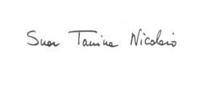
(Book of Numbers 6, 24-26)

Suor Tanina Nicolaio
Superior General

Ariccia, April 22, 2021

